**Invitation to an Public Meeting convened by Thundridge Parish Council to be held at High Cross Village Hall on Sunday 24th June 2018 at 10:30AM.**

As you may be aware, a full planning application has been submitted (3/18/0670/FUL) for the erection of 9 dwellings comprising 5no. 5 bed houses and 4no. 1 bed flats on land to the West of High Road High Cross Hertfordshire (opposite to Cambridge Cottages). For clarity, this site is situated to the North of the site which was recently refused permission (3/17/2216/OUT).

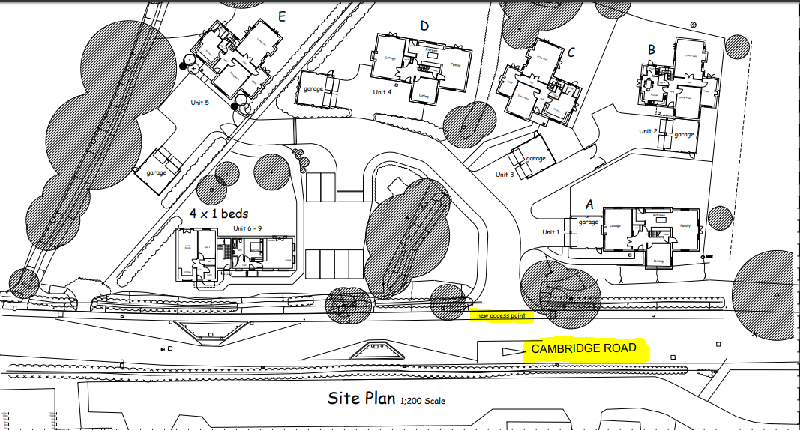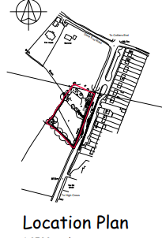

The meeting is being held so that you can guide how Thundridge Parish Council respond to this application so please try to attend the meeting for an open discussion. At the meeting, members of Thundridge Parish Council would like to hear first-hand the views of people living in High Cross and ensure that the Parish Councils response reflects the communities’ views. If you are unable to attend the meeting, please submit your thoughts to the e-mail address for the Clerk in the footer (in addition to submitting your views to EHDC planners).

Comments are required to be submitted to East Herts District Council by 28th June 2018. You are strongly encouraged to submit your views through the EHDC planning system portal or by letter.

*You can access the full details of the application on line as follows:*

*Go to the Thundridge Parish Council Website:* [*http://www.thundridgeparishcouncil.org.uk/*](http://www.thundridgeparishcouncil.org.uk/)

*Select Planning (on the left), then Planning Applications and click on the link for planning applications. Once at the EHDC planning simple search site, enter ‘3/18/0670/FUL’ or the key words: ‘High Cross’ and scroll to this application.*

For those without internet access, we will try to make a copy of the plans available for viewing at the meeting.

It would be helpful (though not essential) if you could indicate how many people from your household may attend (so we can set out the right number of chairs). To do so, please e-mail the Parish Council Clerk at the address given below.

If you wish to object or support this application (please see overleaf), please proceed as follows:

***For those with internet access:***

*Go to the Thundridge Parish Council Website:* [*http://www.thundridgeparishcouncil.org.uk/*](http://www.thundridgeparishcouncil.org.uk/)

*Select Planning (on the left), then Planning Applications and click on the link for planning applications. Once at the EHDC planning simple search site, enter ‘3/18/0670/FUL’ or the key words: ‘High Cross’ and scroll to this application.*

*You will now see the following:*

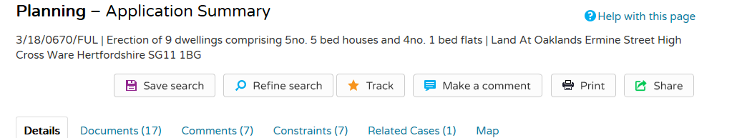

*Select ‘Comments’*

*You will now be in the ‘Make a Comment’ section. Scroll down, enter your details, be sure to select ‘object’, ‘support’ or ‘neutral’ then enter your comment and hit submit.*

*Tip: If you have a long comment to add, it may be easier to prepare the comment in advance and then paste it in.*

***For those without internet access:***

Please write to the Planning Department being sure to quote ‘3/18/0670/FUL’ indicating that you object, support or are neutral. Letters should be sent to:

Planning (Ref. 3/18/0670/FUL) East Hertfordshire District Council, Hertford Office, Wallfields, Pegs Lane, Hertford, SG13 8EQ

**All comments must with EHDC before 28 June 2018.**

Delivered to your door by Thundridge Parish Council