***LAND WEST OF HIGH ROAD OPPOSITE SCHOOL AND CHURCH, HIGH CROSS***

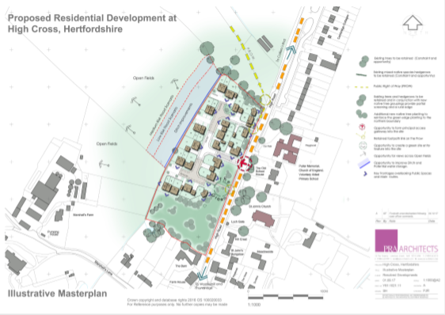

An application has been made to build more houses in High Cross.

The East Hertfordshire District Council Development Management Committee (DMC) will meet on Wednesday 25th April, 2018 at 7:00pm in The Council Chamber, EHDC Offices, Pegs Lane, Hertford, SG13 8EQ. The outcome of this outline development application will be decided at this meeting and may be influenced by your presence. It is the first proposed development on the Planning agenda: 3/17/2216/OUT - Outline application for 27 no. dwellings at Land west of High Road, High Cross for Caddick. Once this session is over, there will be a break allowing you to leave the meeting.

The EHDC Planning Officers have decided to recommend REFUSAL regarding this development. Your Parish Council, guided by public opinion, is also strongly opposed to it. You can view the details of the meeting along with officer’s explanation for their recommendation on the EHDC website (see DMC Agenda).

Whether you are in support or opposition to this proposal, there is also still time to influence David Andrews (our District Councillor) who is a member of the committee. He can be reached at: david.andrews@eastherts.gov.uk If you do contact David, it would be helpful if you could copy in the Parish Council as well at the address shown at the bottom of this letter. Please note that your attendance will aid Councillor Andrews with stating his opposition to the development during the meeting. If you do choose to attend the meeting, you should also be aware that car parking space is limited.

Official notice…….

Notice to Parish / Town Council

Town and Country Planning Act 1990 (as amended)

Dear Sir/Madam APPLICATION: 3/17/2216/OUT PROPOSAL: Outline application for 27no. dwellings - all matters reserved except for access AT: Land West Of High Road High Cross Hertfordshire FOR: CADDICK LAND I am writing to inform you that the above mentioned planning application will be presented to the 25th April 2018 Development Management Committee. The meeting will be held at 7.00pm at The Council Chamber, Wallfields, Pegs Lane, Hertford, SG13 8EQ. A copy of the agenda is available on the District Council website, using the following link <http://online.eastherts.gov.uk/moderngov/ieListMeetings.aspx?CommitteeId=118>.

Delivered to your door by Thundridge Parish Council