**Guidance on how to make comments on the appeal by Beechwood Homes against the decision to deny them planning permission to build 20 houses on the Glebe Field, North Drive, High Cross.**

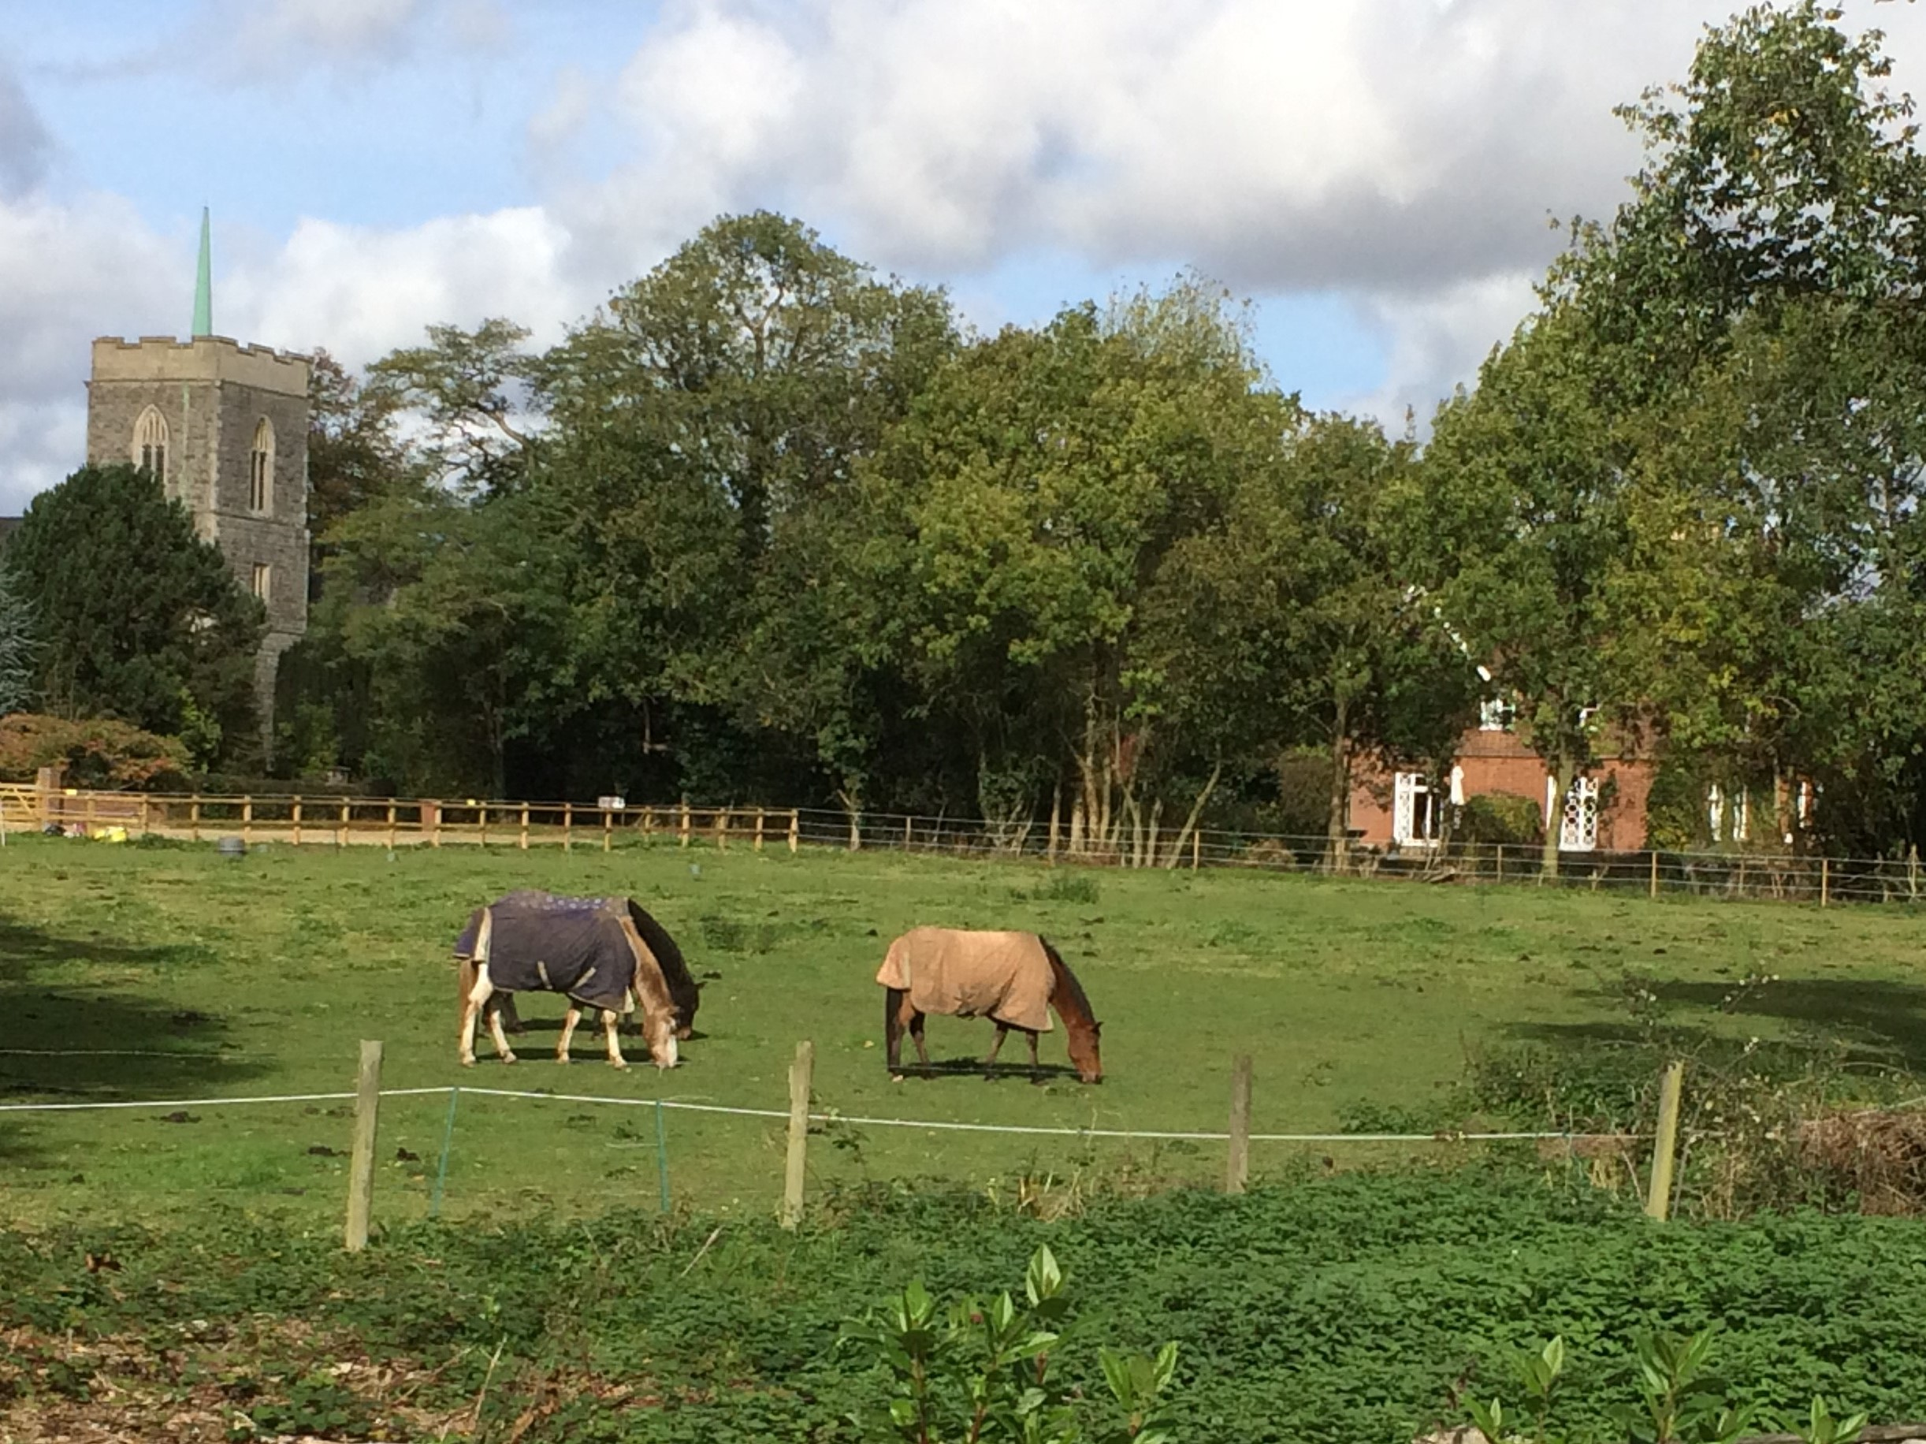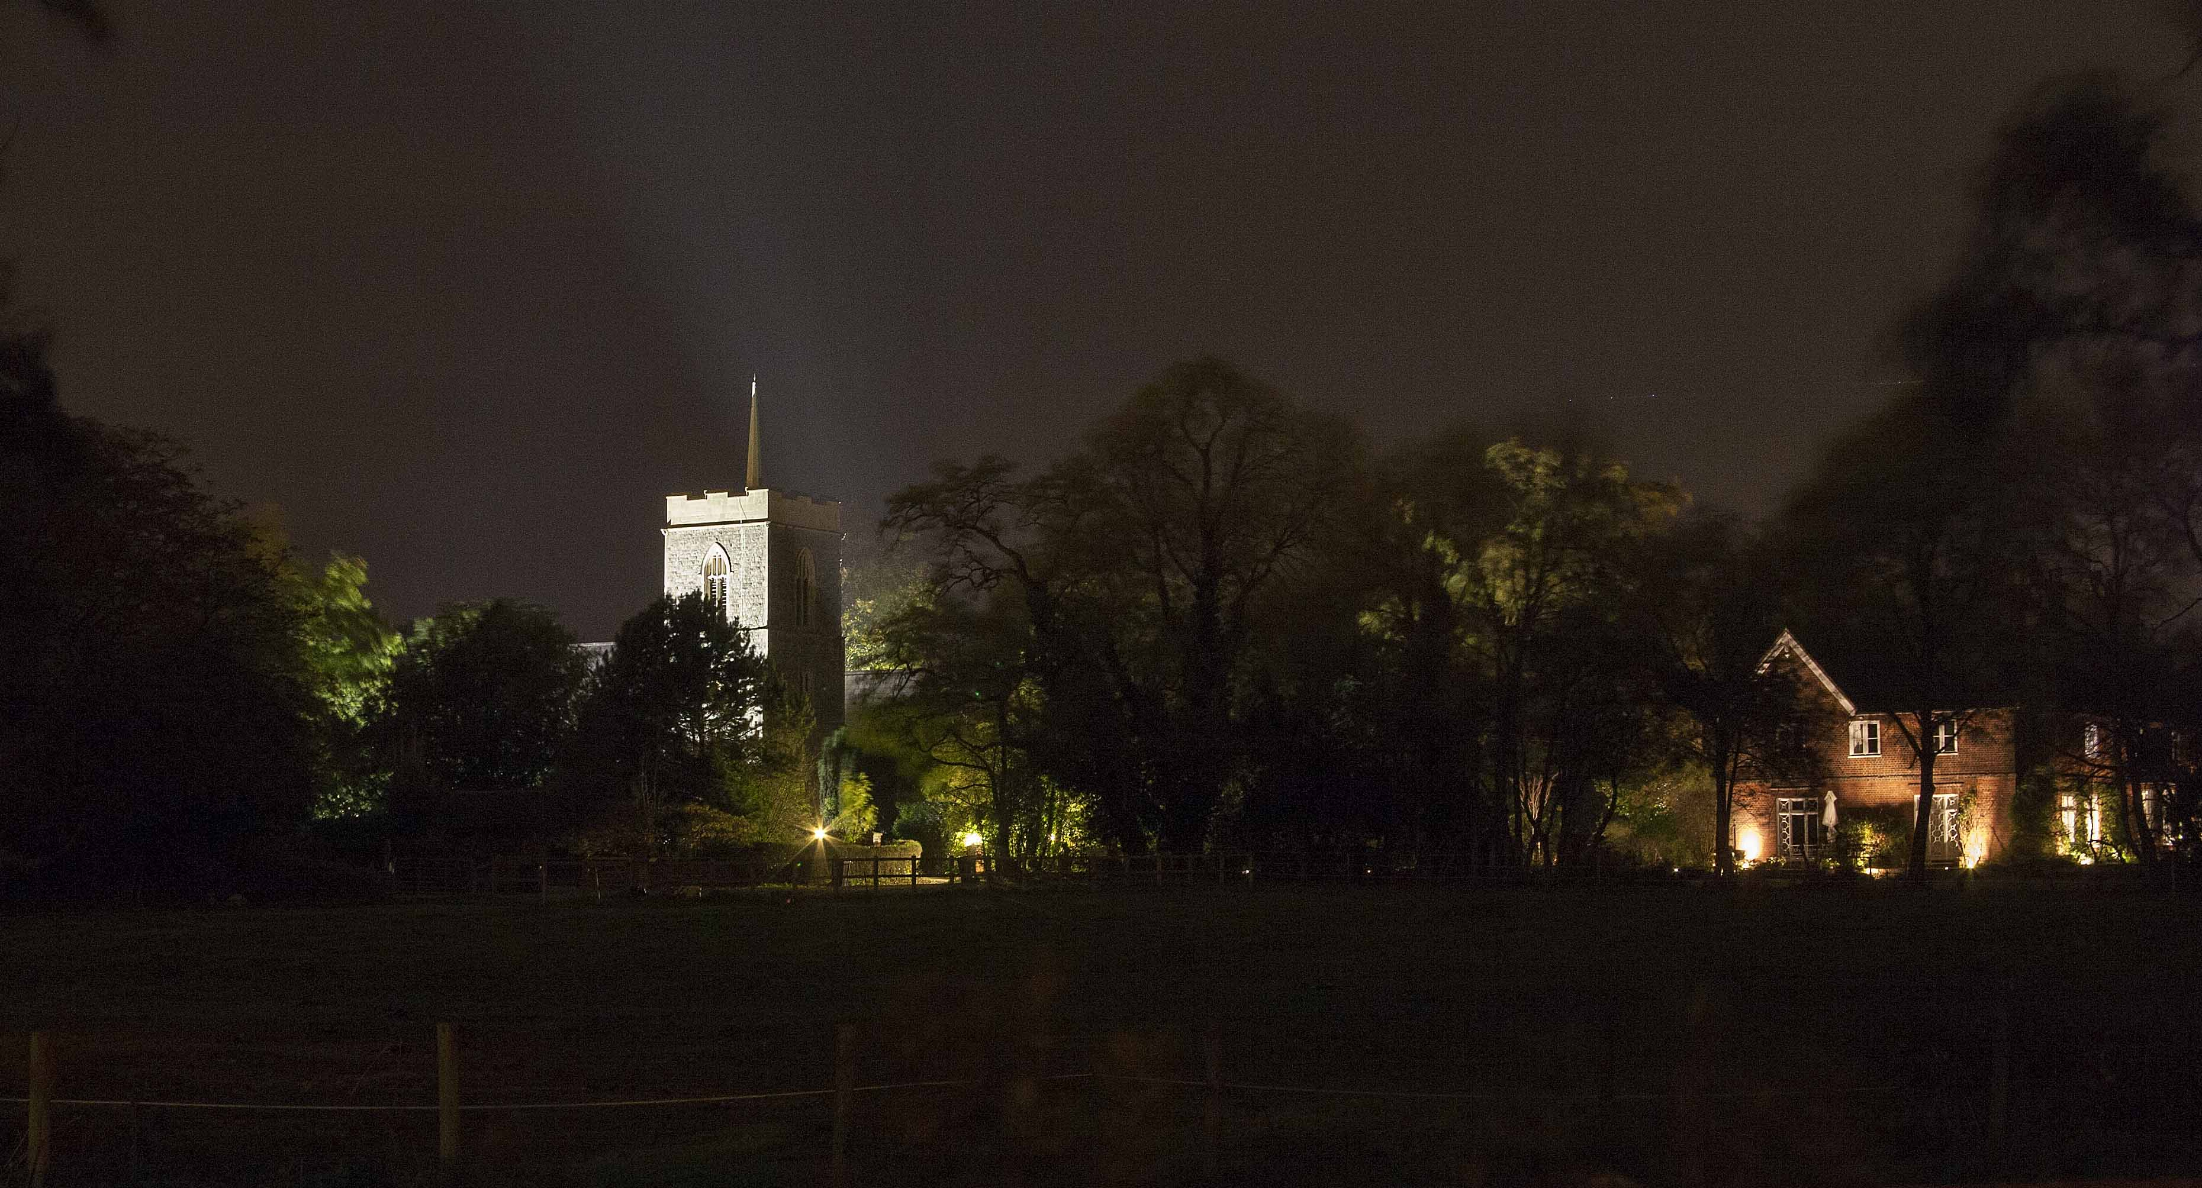

If you are keen to help in the fight against the development of the Glebe Field, now is the time to act. Comments need to be with the inspectorate by 21 November 2017. Please be aware that if you have already written to EHDC, your letter will have already been forwarded to the inspectorate by EHDC, so there is no need to repeat your previous comments (though it is fine to reference your previous communication). New comments should focus on new information and/or your specific response to items in Beechwood’s appeal document. To provide you with guidance on areas that may be appropriate to mention in your submission, we have provided the following guidance. Please pick topics that you feel most strongly about and be sure to reword any points that you choose to make and not just repeat the points below as listed.

The three main reasons, given by the appellant, to justify their appeal are:

1. That their planning application is in accordance with the Development Plan
2. That the Council cannot demonstrate a five-year housing land supply
3. That there will be no harm to the historic significance of St John’s Church or The Rectory

***You can refute*** *Beechwood’s reasons to justify the appeal as follows:*

**1. Application is not in accordance with the Council’s Development Plan** The proposal is not in accordance with the current Development Plan i.e. East Herts Local Plan, nor is it in accordance with the policies in the emerging District Plan (currently undergoing examination). These are clearly set out in the Council’s decision notice (available on EHDC Planning Web Site).

**2. Indications are that the emerging District Plan is sound** The appellant’s justification for appealing the refusal of planning permission is primarily based on the Council not being able to demonstrate a five-year housing land supply. Early indications from the District Plan Examination are that the plan is sound and so the issue of no five-year land supply should be discounted. **3. Substantial harm to the setting of two listed buildings (heritage assets)** The Church of St John the Evangelist and The Rectory are Grade II listed buildings. Both are seen across Glebe field from a long stretch of North Drive. As the Council said in its decision notice, with St John’s Church and The Rectory located to the north, Glebe Field plays an important role in the setting of those heritage assets.

*You can* ***support the Council’s reasons for refusing the planning application*** by making the point that there will be a significant harmful impact on the village if the field were developed as follows:

* **Glebe Field** is an undeveloped area of land in the centre of High Cross and performs an important function as the heart of the village
* **Glebe Field** is as an open green area which forms an integral part of the character of the village

There are also a number of assertions made by the appellant that **you can refute** by pointing out the following**:**

* An important part of the site history is that the Council refused an application for Dog Training Activities in 2011. Although not the reason for the rejection, it should be noted that an EHDC planning officer wrote the following in his report: *“this plot of land is of particular aesthetic value worthy of retention, representing a significant open space, important to the form and setting of the village”.* Recent development on green space in the village has increased the importance of retaining this field.
* The proposed short-term improvements to North Drive will not include a pavement and the new surface would allow traffic to move faster. If you don’t think the improvements to North Drive will be a positive long-term public benefit then you should say so.
* Although an on-line public consultation exercise was undertaken it was critically flawed because it was impossible for respondents to express their objections to the proposal. The consultation carried out by the Parish Council in an open meeting where 80 residents present showed unanimous opposition and the written responses to the application, accurately reflect the village opinion.
* Reference to the Thundridge Parish Neighbourhood Plan mentions only that the area for a Neighbourhood Plan has been designated. Beechwood have not engaged with the Neighbourhood Plan Advisory Committee. The Plan is progressing well. The results of the detailed survey that was completed by over 32% of households in the parish will be presented at a Consultation on Saturday 11th November in Thundridge Village Hall (at 10:00).
* Sustainable development should provide positive improvements in the quality of the built, natural and historic environment:
  1. It is not possible to build 20 houses and achieve the local, national and European requirement for ‘no net loss in biodiversity’.
  2. The development will have a negative impact on the historic environment by destroying the green and open setting of St John’s Church.
  3. The design of the new homes reflects only the character and density of the unpopular town style of development in Canterbury Park.
  4. Any loss of car parking for the village hall puts this valuable amenity at risk and therefore be contrary to social sustainability.
  5. The appellants say that the development would allow views into the site – in reality, what is important to residents are the *unrestricted* views across the site.
  6. The proposed removal of trees on the site is unnecessary and unwanted.
  7. The assertion that building on the field would open up a safe route to the school, church and petrol station is ludicrous!
  8. The benefit of 20 new homes towards the Council’s housing requirement does not outweigh the harm that would result to the quality of life of the local community if they were built on Glebe field.

**Please write to the Planning Inspectorate at Temple Quay House, 2 The Square**

**Temple Quay, Bristol, BS1 6PN.** Quote reference: APP/J1915/W/17/3181608

**Or submit your representation on-line at:** [**https://acp.planninginspectorate.gov.uk/ViewCase.aspx?caseid=3181608**](https://acp.planninginspectorate.gov.uk/ViewCase.aspx?caseid=3181608)