East Herts District Council 14th March 2017.

Wallfields

Pegs Lane

Hertford

Dear Sirs

Objection of Thundridge Parish Council to planning application:

**3/17/0251/FUL**

**Erection of 21 dwellings with associated parking, landscaping and access at North Drive, High Cross**

**Introduction**

The proposal does not represent sustainable development and the adverse impacts of granting permission would significantly and demonstrably outweigh the benefits when assessed against the principles and policies in the National Planning Policy Framework (NPPF) and both the adopted policies in the East Herts. Local Plan (2007) and the emerging policies in the East Herts. District Plan 2011-2033. On this basis (and many others listed below as well) the application should be refused.

The Parish Council is empowering local people to be involved in the preparation of a Neighbourhood Plan and although not ready for submission, initial indications from the Neighbourhood Plan Environment Group are that Glebe field would be designated a Local Green Space in the plan.

More than 80 village residents attended an open meeting of Thundridge Parish Council to specifically review planning application3/17/0251/FUL in High Cross Village Hall, on Sunday 19th Feb 2017. When asked for a show of hands, those present were unanimously opposed to the development. The Parish Council is therefore representing its Parishioners in objecting to the planning application.

The following paragraphs consider how the proposal upholds the planning principles in the NPPF and whether the development is sustainable. There are no social or environmental benefits for the Parish; the only benefit that could result from the development is the reconstruction and adoption of North Drive and even that is not clearly defined in the proposal.

Thundridge Parish Council has identified many issues, detailed in the latter sections of this objection statement, with the applicants Statement of Community Involvement and the documents accompanying the application including the application form itself. This indicates how poorly conceived the scheme is and the lack of attention to detail in preparing the application. The resulting proposal is full of false impressions, incorrect facts and false assumptions.

The Parish Council is confident that the plans will be rejected, but has still prepared a thorough list of conditions which the Parish Council would require to see attached to any permission that may be granted on the site.

**Planning Principles**

The development does not comply with the core land-use planning principles set out in the NPPF. In particular:

* It is not plan-led as it conflicts with policies in both the existing and emerging local development plans.
* It does not enhance or improve the village of High Cross; it will detract from the open feel of the centre of the village comprising St John’s Church, The Rectory and Glebe field.
* It does not adequately take full account of flood risk; surface water is discharged into the adjacent watercourse that has a history of flooding on a regular basis. Recent improvements to this watercourse are yet to be proven.
* This proposal does not encourage the reuse of existing resources or use of renewable resources.
* It does not contribute to conserving or enhancing the natural environment; it would reduce the biodiversity value of this unimproved grassland surrounded by mature trees and bushes.
* It does not reuse land that has been previously developed; the site is and always has been a green field.
* It does not conserve heritage assets; irreparable harm would be caused to the setting of the grade II listed Rectory.
* It adds a significant (in comparison to the size of the village) amount of development in a location, which is not sustainable.
* It delivers no community or cultural services to meet local needs.

**Sustainability**

Village Policy

The biggest issue surrounding sustainability is the classification of High Cross as a Category 1 (relatively sustainable village) in Policy OSV1 (2007 Local Plan). The subsequent re-evaluation of the sustainability of the village, which has resulted in it being downgraded to a Group 2 village in Policy VILL2 (District Plan 2011-2033), implies that it is only suitable for limited infill development.

This development of 21 houses does not constitute limited infill because it does not fill in a gap in the frontage on North Drive between existing residential properties. It is in itself a green field with a frontage of 90 meters, including the lane to the church. Nor is it small in scale. When considering the recent addition of 62 dwellings (including Canterbury Park) to the village, the overall addition of 83 houses in a very short period of time represents unacceptable over-development.

If a further 21 homes is deemed to be required in High Cross, **it is inconceivable that an alternative, less controversial and detrimental location for these houses cannot be readily found** inside or adjoining the village boundary. This process will be undertaken as part of the preparation of the Neighbourhood Plan.

The Parish Council believes that the original classification of High Cross as Category 1 in the 2007 Local Plan was a mistake and supports the correction of this mistake by reclassifying the village as Group 2 in the District Plan 2011-2033. The village should not be forced to suffer any further from the consequences of this mistake.

The Parish Council strongly disputes that the development is sustainable in this location.

The Value of the Site as a Green Space

This green field is an essential green space, which should be retained at the heart of the village in order for the village to thrive. This is supported by local plan policies, the results of the SLAA assessment as part of the preparation of the submission version of the District Plan 2011-2033 and previous planning refusals on the site.

The SLAA site reference 42/017 is described as a green field site which lies within the village boundary. While very well related to existing development, it was considered that this site performs an important role in maintaining the character of the village and is therefore unsuitable. The site was promoted through the Call for Sites by the landowner and was considered to be available. The site was also considered to be achievable in terms of economic viability, but not deliverable or developable even with a change in policy.

The adopted policies in the 2007 Local Plan that apply to this application support the protection of this space. Policy OSV1 says that development may be permitted provided that *“(e) the site does not represent a significant open space or gap important to the form and/or setting of the village”.* Glebe Field is of particular aesthetic value worthy of retention and representing a significant open space, important to the form and setting of the village.

Emerging Policy VILL2, which applies to High Cross, says that limited infill development will be permitted as long as it does*“(d) Not represent the loss of a significant open space or gap important to the form and/or setting of the village”.*

So, whether the adopted policy or the emerging policy is applied, the principle of retaining the green space is upheld.

When an application for use of the site for dog training activities was refused in 2011 (3/11/0427FP), the planning officer’s committee report stated:

***“With regard to visual amenity, it is my opinion that this plot of land is of particular aesthetic value worthy of retention, representing a significant open space, important to the form and setting of the village”.***

Unfortunately, the assessment of High Cross for Conservation Area status is caught in a backlog of work within the planning department. However, it is the view of the Parish Council, that should the heart of the village be designated a conservation area, Glebe Field would be recognised as ‘an important open space to be protected’ in line with similar spaces within other nearby villages, e.g. Braughing.

The applicant does not consider or assess the importance of the green space to the village, only the dubious economic benefits of building on the space. The Parish Council argues that Glebe Field should be retained in perpetuity for the benefit of the village and will in due course be designated a Local Green Space through the Thundridge Neighbourhood Plan.

**Environmental and Social Issues**

There are many social and environmental adverse impacts that would result from this development and the Parish Council argue that together with the cumulative effects of other recent development in the village, the harm to the village and its residents, significantly and demonstrably outweighs this benefit of an additional 21 homes to East Herts 5-year land supply. These issues are set out below.

Loss of Trees

When Beechwood Homes presented their initial plans for the Glebe Field to the Parish Council, they stated that they would be retaining 97% of the mature trees on the site. In the document titled ‘Tree Retentions and Removal Plan’, it is clear that very many of the mature trees are proposed for removal. The Planning Statement (paragraph 6.57) says that the tree removals are required to fit in the proposed plan. This is not acceptable to the Parish Council; instead, the plan should be modified to accommodate the existing trees without any removals.

The extensive removals in the vicinity of the site entrance and plots 15, 16, 17 and 18 (referred to as Group 3 and group 4)will completely remove the only screening between the existing North Drive Houses (15, 17, 19 and 21) and the proposed development site. These houses are already significantly impacted by the Canterbury Park development to their South, West and East.

It is further noted in the Planning Statement (paragraph 6.59), that many of the removals near plots 15-18 are required due to the installation of the David Wilson Homes North Drive flood avoidance scheme. In discussion with David Wilson Homes, this is not the case as the trees have spent the last 50 years living on the edge of a ditch and have not been significantly disrupted. These trees should be retained.

Ecology and biodiversity

There is no nett gain in biodiversity demonstrated in the application. This is a requirement or all sustainable developments. The Herts and Middlesex Wildlife Trust has recommended refusal of the application based on an inadequate Ecological Appraisal. The site may well represent a priority habitat that should be improved and enhanced. This would be unachievable and completely incompatible with the proposed development of 21 homes and would be unachievable.

Risk of Flooding

The distributor road within the site is shown on planning documents as asphalt/macadam. In the Canterbury Park estate, the main road design is of semi-permeable material and this site should be the same. The other greater concern about flooding is the concept that the surface water should flow into the ditch in the South East of the site. The flood avoidance system installed by David Wilson Homes as a condition of the Canterbury Park development has only just been connected in mid-February 2017. Initial calculations used to build the system should be re-worked to ensure that the additional flow remains within specification. This includes reviewing the downstream capabilities, south of Canterbury Park. The need to allow drainage schemes to be validated over a period of time (at least one full year) is made evident by the fact that David Wilson Homes are experiencing flooding issues in the gardens on their site despite their fully approved on site drainage design.

Impact of insufficient residents and visitor parking spaces

In the individual house designs, the open market houses show garages included as parking spaces. The Parish Council have reviewed the garage facilities in Canterbury Park and it is clear that very few, if any, of the garages are actually used for parking. Furthermore, Canterbury Park residents have already converted garages for other uses (such as garden room with front bricked up) removing these ‘parking spaces’ permanently. Based on real life evidence, these garages should not be considered parking spaces.

The Parish Council believes that the number of parking spaces allocated to the ‘affordable houses’ is insufficient in number, size and design. The lack of spaces is a practical consideration and is based on real life observation of Canterbury Park where parking has been demonstrated as inadequate. Because of recent experience, the Parish Council is able to raise these issues specifically as a consequence of real world evidence.

The size of the parking spaces is also inadequate based on the fact that they only accommodate domestic cars with no allowance for small commercial vans, owned by new residents that will need to be accommodated within the site.

The layout of the car parking spaces is also an issue. The parking of cars (nose to tail) is impractical and out of keeping with other houses in North Drive, who all have adequate parking spaces for residents and visitors within their curtilage precisely because there is no parking space on North Drive itself.

Impact on Heritage Assets

Although no Heritage Statement has been produced, the developers own Archaeological Desk Based Assessment report concludes that the proposed development will, both during construction and afterwards, have a “high” negative impact on The Rectory and its setting, the rural character of the area and the views to and from The Rectory.

The photograph below shows a 60m radius around The Rectory where the development will cause irreparable damage to the setting of this important building, which contributes to the character of the village.

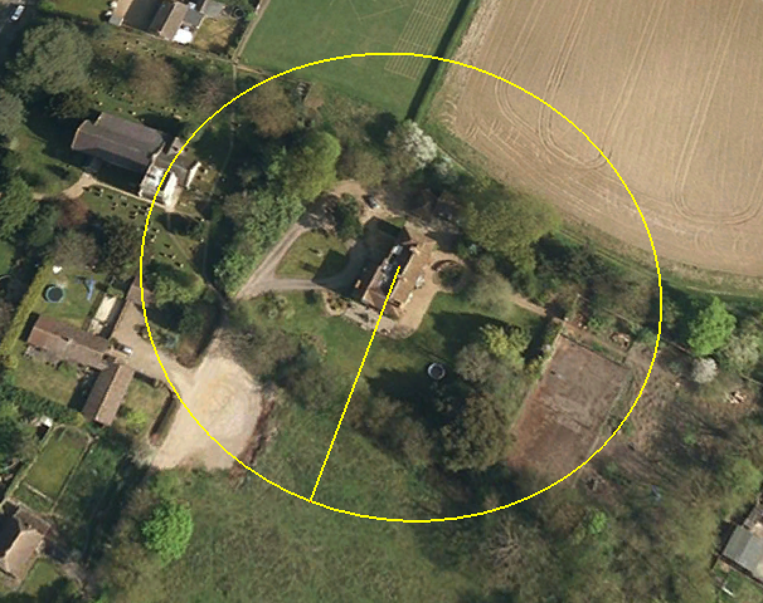

View of the church and Rectory

North Drive (and the houses on it) presently enjoy an open aspect (across the proposed development site) featuring the grade II listed Rectory and St. John’s Church. At night, the Church, along with it Hertfordshire spire is beautifully illuminated offering an inspiring view especially on a misty evening. This development will completely obliterate this valued view from North Drive shown in the photograph below.

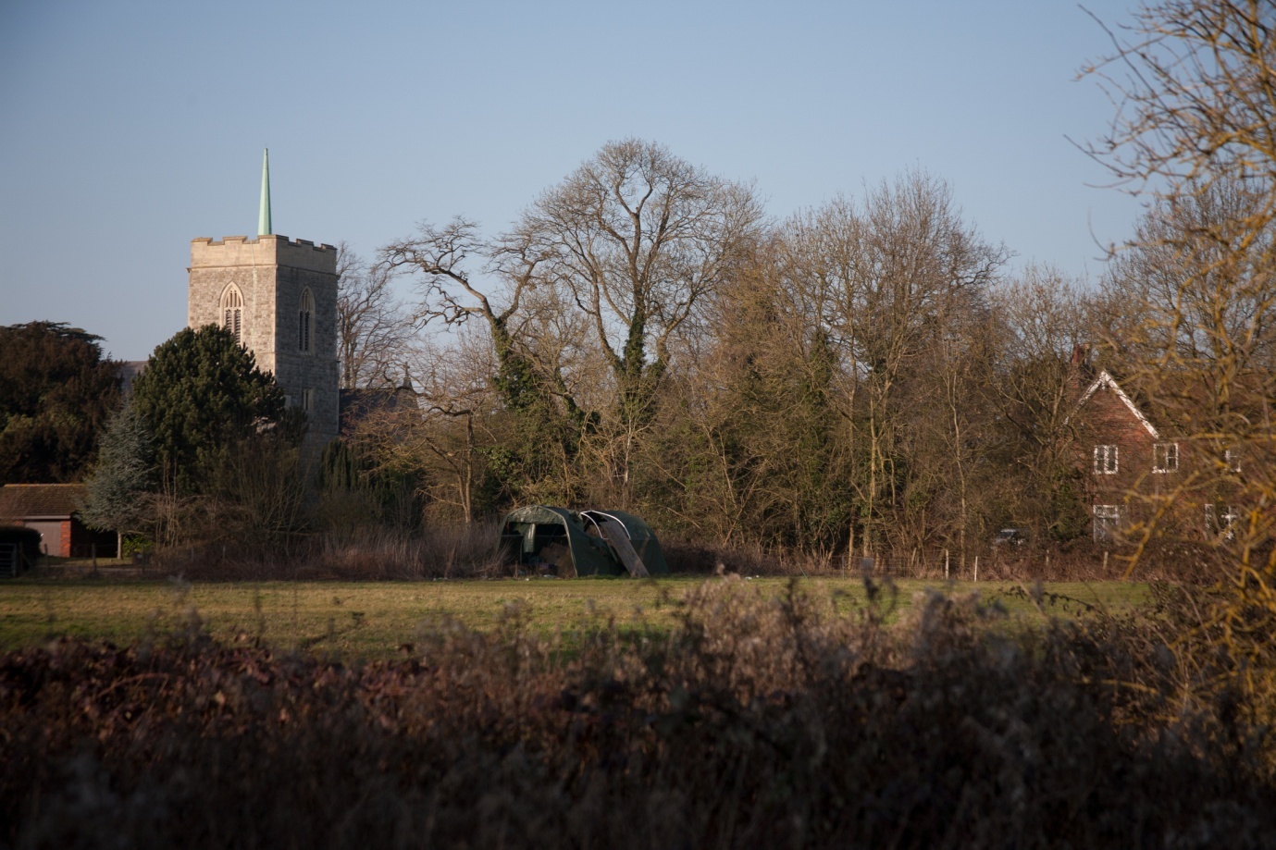

Height of the development

Drawing number 22429A/101 clearly demonstrates that 2.5 storey houses are unsuited to this type of village development (as is now so very clear, in retrospect, with Canterbury Park). An illustration of the over-imposing nature of the 2.5 storey house is demonstrated when comparing the front elevations of plot 11 vs. Plot 10.

The photograph below shows the impact of artificially raised ground levels on the Canterbury Park Development as viewed from a house on the south side of North Drive, directly opposite Glebe Field.

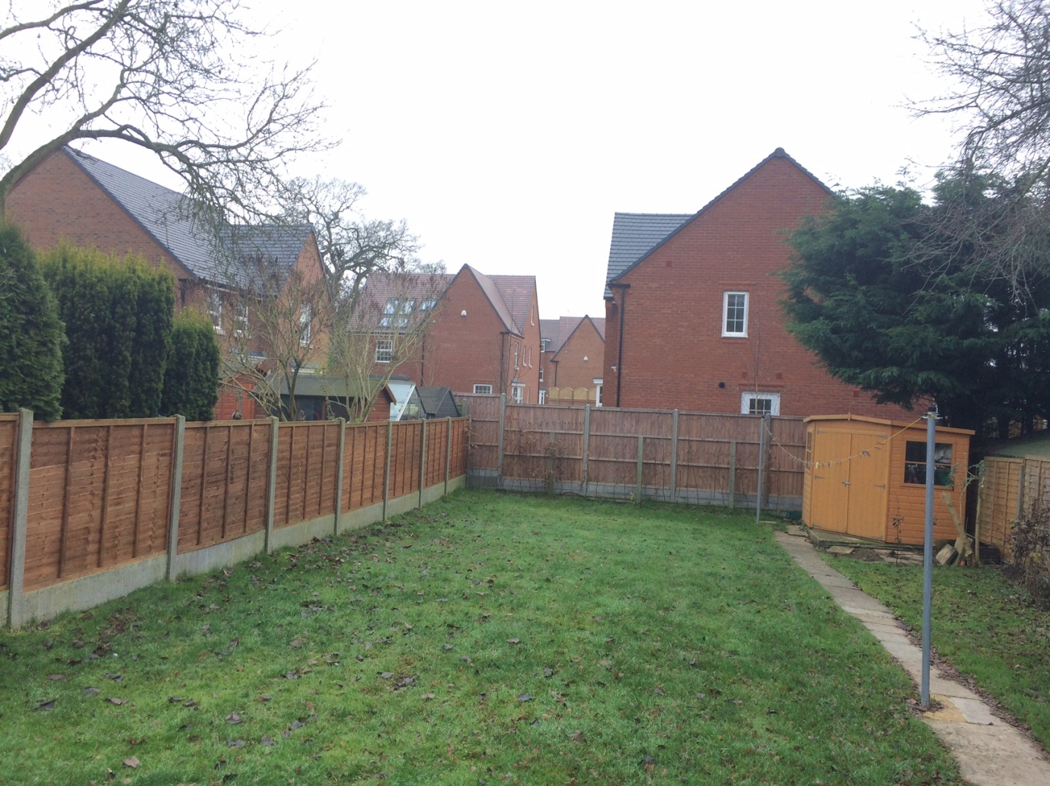

Effect on the street scene

The layout, height and intensity of the development will negatively impact on the street scene, which currently provides a view of the open space and church along the length of North Drive, up to the farm entrance. The photo below taken from Page 6 of the Design and Access Statement contradicts the applicant’s own statement on Page 13 of the Design and Access Statement regarding the proposed street scene “that view is restricted unless you are standing in the field”. The current view is available the length of North Drive up to the farm entrance

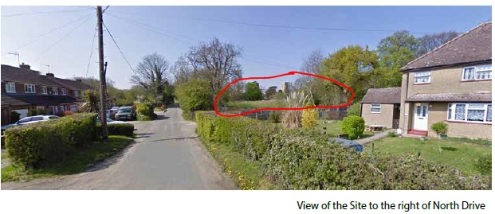

The application fails to show an impression of the new street scene when the development is completed. It is clear from the plans that homes on the southern edge of the site present only their rear or side views to North Drive.

Intensity and layout of development

Policy HSG7 (2007 Local Plan) states that proposals for infill housing development in Category 1 Villages will be permitted provided that they are well sited in relation to the remaining surrounding buildings and will not appear obtrusive or over intensive. This is not the case with this application. The proposal creates exactly the type of cul-de-sac arrangement that East Herts planners have openly criticised. It bears no relationship to the surrounding homes which all front onto North Drive. In fact, it is totally inward looking and appears that it has been designed without any reference to its surroundings. The design and layout of this development is fundamentally flawed.

High Cross village is an attractive rural village and this site is a green space in the heart of the village. In the unacceptable event that the Parish Council is unsuccessful in convincing East Herts Council to refuse permission for development on Glebe field, then the village deserves a well designed scheme which relates to its surroundings and recognises the value of the site to local residents.

Risk to the viability of the village hall

There is a significant risk that the Village Hall car park and the church car park will be used for overflow and car and van parking by the residents of the proposed development. The development proposes to narrow the width of North Drive to the south of the proposed development. This is an area that is currently used as overflow Village Hall and Church parking. Narrowing this section of the road and removing the ability for casual parking on occasions when the hall is being used for village events will inevitably impact the viability of the Village Hall as a public venue. If this venue became unviable, the loss of the hall would be a severe negative social impact on residents in the village.

Anti-social behaviour

Page 8 of the applicant Design and Access Statement suggests that this development will produce a safe and secure environment. However, it is the informed view of the Parish Council that the development will lead to a deterioration of the broader social environment of the village. This view is based on the known impacts on the village of the Canterbury Park estate. The Canterbury Park development has massively increased the crime figures within the village and changed the ‘feel’ of the village accordingly. Based on a recent presentation to the Parish Council the EHDC ASB Officer, the ASB Officer of B3 Living and the Police have all advised the council that ‘it will take time for these issues to be resolved and we must be patient’. To build additional houses in the Village so soon is not providing this recovery time.

**Benefits of the development**

There are no social or environmental benefits of the development. The only benefit for the residents of North Drive and Poplar Close would be if the development included the reconstruction of North Drive, to the entrance to Home Farm and the subsequent adoption of that whole length of road by Hertfordshire County Council, to ensure its future maintenance.

Improvements to North Drive

North Drive is officially unadopted except as a bridle way. Access to North Drive is an issue that has been recognised in the reports. One of the mitigating plans is to increase the visibility splays on both sides of the junction with North Drive and the High Road. The Parish Council completely agree that this junction, as well as the entire road itself represent a major safety issue relative to this development and note that even the David Wilson development was completely barred from allowing any vehicular access from North Drive. The Parish Council want to point out that there is NO PRACTICAL WAY to increase the visibility on the North Drive / High Road junction. To the North of the junction, large vehicles regularly park directly outside the garage either while making deliveries or while visiting the SPAR shop. This completely removes the visibility to the North and cannot be changed. Directly to the South of the junction is a bus stop which again completely removes the visibility to the South every time a bus or indeed other unauthorised vehicle) is present. This is further compounded by the North bound bus stop which is again almost directly opposite the junction. On North Drive itself, vehicles park sometimes on both sides of the entrance severely restricting the access. For all of the reasons above, the District council’s previously adopted stance to allow no further vehicle access off North Drive is completely correct and must be maintained.

North Drive is too narrow and has a dangerous junction with High Road. It has no parking restrictions and the Parish Council recognise that there can be no reliance placed on the enforcement of any such restrictions in the future.

Regarding other proposals for North Drive, it is unclear whether the proposals will deliver long-term improvement to North Drive. The most common reference in the planning application supporting documentation is to resurfacing with one reference to ‘making up to adoptable level’. None of the proposals offer a clear permanent solution for North Drive, only a short-term improvement. It is noted that the requirement of the Highway Authority to resurface North Drive to its satisfaction is not an assurance that these works will be reconstruction, rather than just resurfacing.

It should also be noted that there is no solution offered for the un-adopted lane to the church. This road is the source of considerable floodwater coursing down onto North Drive. If this is not corrected, any other improvements in North Drive will be washed away in a short period of time. Furthermore, there is no detail in the plans as to how surface water from the new development would be intercepted and prevented from flooding onto North Drive.

The impact of the reconstruction of North Drive will surely impact on the viability of the scheme. **Has this impact been calculated and are Hertfordshire County Council committed to adopting the road?**

During David Wilson Homes roadworks to install the drainage ditch across North Drive recently, there was a temporary system installed that attempted to calm the traffic in North Drive by installing an effective give way system that was almost identical in nature to that contained in this proposal. This failed very badly and resulted in cars using private driveways as a means to pass oncoming cars. This idea proposed in the Transport Statements s.4.3.1. to ‘provide give way traffic calming features’ on North Drive needs to be formally trialled and revised or abandoned prior to any decision being made on this proposal. Getting North Drive right is a critical safety concern as older people, disabled motor scooter users and school children use the road extensively.

The proposals to install over runnable footways on North Drive, detailed in the Design and Access Statement will not actually improve the usability of North Drive and will simply add unmaintained lines on the road. Further, it will run the risk of vehicles parking on, it thereby blocking the sight lines. These footways will become blocked with cars, forcing pedestrians to walk in the roadway.

The reconstruction of the road without adoption and future maintenance by the County Council will be nothing more than an interim solution and not a long-term benefit as claimed. Simply resurfacing the road, as proposed in some documents supporting the application, has even less value.

**Issues with the Applicant’s statement of Community Involvement**

The applicant’s attempts at public consultation prior to the submission of the planning application were poor.

The survey was difficult to fill in and did not allow residents to express their objection to the application proposal. The on line survey sent out locally in High Cross contained significant errors which prevented residents selecting negative responses to the questions.

Of the 35 respondents to the online survey, when asked if they were in support of new housing in High Cross, 33 answered ‘No’ and only 2 answered ‘Yes’. This does not imply that the two people who answered ‘yes’ thought that the new housing should be built on Glebe Field. The surveys that were completed as a result of canvassing failed to ask a similar question. No question in either survey specifically asked whether Glebe Field was the right location in the village or in North Drive, for 21 new homes.

It is also unclear whether the respondents to the canvassed survey were the same as those residents who completed the online survey. This was an ineffective exercise and the officers and Development Management Committee members should defer to the consultation carried out by the Parish Council and the representations received from village residents to gauge how people in the village feel about the development.

**Issues with planning application documents**

The following items have been identified as issues with the planning application form, the Planning Statement, the Design and Access Statement or the application plans. These matters should be resolved before a recommendation is made to the Development Management Committee. The Parish Council will also wish to re-review the corrected documentation.

The Planning Application Form:

Paragraph 12 of the planning application form states that there are no watercourses within 20 meters of the site but that surface water will be disposed of into the existing watercourse. This is clearly contradictory.

The Planning Statement prepared by Boyer (Jan17):

Paragraph 2.2. This indicates that the site access is presently from North Drive. This is incorrect as the site is currently accessed from a lane leading northwards off North Drive to the church car park. Punching a new access into the frontage of Glebe Field from North Drive will again result in the loss of existing protected trees.

Paragraph 2.4. The report fails to state that the approval 3/13/2223/FP (Canterbury Park), while being granted also specifically denied any vehicular access to or from North Drive as the road was not considered suitable to take construction traffic or the additional traffic. This is strictly enforced through the provision of a Ransom Strip between the development and North Drive.

Paragraph 2.6. An earlier application to convert this field from agricultural to dwelling use was also rejected (3/61/0268).

Paragraph 6.4. The fact that the site is located within the settlement boundary and is surrounded by residential dwellings on three sides does not mean that it meets the criteria of saved policy HSG7. As stated in paragraph 6.4 proposals for infill housing development in Category 1 Villages will be permitted provided that they are well sited in relation to the remaining surrounding buildings and will not appear obtrusive or over intensive.

Paragraph 6.7. States, regardless of whether the adopted or emerging Local Plan is applied, the site provides a sustainable location. This is untrue in relation to a development for 21 homes. 21 new homes in a correctly defined Category 1 village may well be sustainable, but East Herts Council has corrected its mistake of categorising High Cross as one of the more sustainable villages and now agrees that the village is only suitable for limited infill that satisfies 7 criteria.

Paragraph 6.7. The exact nature of the Highway improvements mentioned in this paragraph are not clearly defined and as such cannot be considered a benefit unless they include the complete reconstruction of North Drive from High Road to the entrance to Home Farm and the subsequent adoption of the road by Hertfordshire County Council.

Paragraph 6.8. The SMHA does not identify a need for flats over garages, which are completely out of keeping with the existing homes in High Cross.

Paragraph 6.10. The addition of 21 dwellings does not strengthen the village as a local service centre as no additional services are proposed.

Paragraph 6.12. The development would not provide a positive environmental contribution but would destroy a green field of unimproved grassland and a number of mature trees (see also the objection of the Herts and Middlesex Wildlife Trust). The site is the natural habitat of a variety wildlife including but not excluded to Muntjacs, wild hedgerow and farm land birds and bats that would all be displaced as a result of the development.

Paragraph 6.26. The statement that “All proposed gardens are considered to be of a suitable size which reflect the character of the surrounding area.” is inaccurate. The densest area of development in the vicinity of the site are the properties on the south side of North Drive at 20 dwellings per hectare, with each home having its own private amenity space. Four of the proposed new units have no private amenity space, which is not appropriate in a village location.

Paragraph 6.30. Because of the current poor state of the road, this should state ‘completely re-build and ensure adoption by Hertfordshire County Council’ of North Drive to an adoptable standard, not ‘Resurfacing of North Drive” which will at best offer a very short-term improvement only.

Paragraphs 6.59 & 6.60. This is incorrect; these trees do not need to be removed to execute the drainage works (which have recently been completed).

The submitted documentation conflicts in many places both as to how much of North Drive will be impacted and also to what extent.

The Design and Access Statement Rev A

Page 2. The site is described as including North Drive; this is correct only as far as the eastern boundary of the site. Hanbury Manor is described as being located to the north of the site; it is located to the south. London Luton Airport is described as being 15 miles away; the fastest route to the London Luton Airport from High Cross is 26 miles. The commuter train from Ware is described as a fast service. The Parish Council wishes it to be noted that the service is not fast; it is a branch line that takes on average 1 hour to arrive at London Liverpool Street in the rush hour. In addition the service is overcrowded and passengers often find there is standing room only. Out of rush hour the train service is slower and stops at more stations en route to and from London.

Page 3. The village is described as having an ATM; this is incorrect. The village is also described as having a pub; the White Horse is currently closed.

Page 6. There is mention of proposed cycle routes, which will create new links to the wider neighbourhood and promote sustainable movement choices. There is no other mention of cycle routes in the application. The Parish Council requests that the plans for the proposed cycle routes are made available for inspection.

Plans submitted with the planning application

Based on recent experiences with the unusually high elevations of the new houses in Canterbury Park, High Cross, the Parish Council is insistent on seeing drawings that show the detailed levels of the field and adjacent roads and the proposed levels for the houses.

Additional drawings should be submitted to show the new street scene that would result from the development.

**Conditions**

In the event that this planning application receives planning permission either through East Herts Council or on appeal, the following conditions should be applied to the permission.

Amendments to the planning permission

Any amendments sought to the planning permission will be subject to consultation with the Parish Council

During Construction

1. Access to North Drive and the lane to the church should be maintained at all times.
2. No deliveries to the site should occur before 10:00 or after 15:00 to ensure the safety of school children.
3. Site operating hours should be strictly observed.
4. No parking of construction, delivery, workers or other site vehicles to cause congestion or reduce highway safety in other roads in High Cross.
5. Vehicle tyre wash to be available from the start of construction work. This should be made available to residents who may have to suffer from mud left on North Drive.
6. Active communication to be maintained with the community through weekly meetings with a Parish Council representative.

Flood Risk Management

Hertfordshire County Council recommends a condition that says that the flood mitigation measures shall be fully implemented prior to occupation. However, the Parish is more concerned about existing residents living on North Drive.

Flood mitigation measures must be implemented before building work commences to ensure that flooding does not inconvenience surrounding properties and users of the road.

Archaeology

Given the recent information that an archaeological point of interest exists under a driveway within meters of the site, a detailed site survey should be conducted on the land before any construction work commences.

Reconstruction and adoption of North Drive

Thundridge Parish Council should be consulted on full detailed plans of the proposals for reconstruction and traffic calming measures for North Drive prior to any approvals to proceed. The Parish Council also want to see an undertaking by Hertfordshire County Council for full adoption for the road once it has been reconstructed. Soft grass verges should be retained and protected to prevent overrunning/parking.

Lane to the church

As a minimum, the flooding issues arising from run-off from the lane to the church which floods onto North Drive should be resolved. Preferably the lane should be upgraded and maintained by a management company as part of the development. Access to the lane should be maintained at all times.

Church Car Park and Village Hall Car Park and Construction Site Storage

The church and village hall car parks should not be used for parking of construction or indeed other vehicles prior to, during or after the completion of the development. All construction storage should be kept within the site boundary.

Planting

Additional planting to provide better screening of the development from the existing residential properties surrounding the site should be commenced and completed prior to construction work starting on site.

Affordable Housing

Affordable homes for rent, shared ownership or sale should be offered to village residents before being openly offered.

Covenants

Each home should be sold with a covenant to prevent the garages being converted to other uses to maintain the number of parking spaces on site, unless additional parking is provided within the curtilage of the dwelling. In addition, homes should not be extended to the detriment of parking provision within the curtilage of the dwelling.

Street Lighting

Street lighting should be kept to a minimum so as not to spill out of the site to the detriment of surrounding residential properties.

Green Space

The communal green space should be managed in perpetuity through a management agreement.

**Conclusion**

Planning application 3/17/0251/FUL should be refused because it is contrary to local planning policy and does not constitute sustainable development as defined in the National Planning Policy Framework.

Yours faithfully

Belinda Irons